|  |  |  |  |  |  |  |  |  |  |  |  |  |  |  |
| --- | --- | --- | --- | --- | --- | --- | --- | --- | --- | --- | --- | --- | --- | --- |
| 内 容 | 测试四 | | 指针与字符串、结构体 | | | | | | | | | | | |
| 成 绩 | 题号 | 一 | 二 | 三 | | 四 | | 五 | | 六 | | 总分 | 签 名 |  |
| 得分 |  |  |  | |  | |  | |  | |  |
| 姓 名 | 王敏军 | | | | 学号 | | | | 2017112381 | | | | 班 级 | 计算机类 2017-03 班 |
| 专 业 | 计算机类 | | | | | | 指导老师 | | | | 陈 帆 | | 日 期 | 年 月 日 |
| ____________________________________________________________________________________ 报告说明：   1. 编写程序，给出程序代码 2. 给出程序运行结果截图 3. 对测试中未能做出的题目给出问题分析   ___________________________________________________________________________________  **1.** **#include <stdio.h> #include <string.h> int main()**  **{**  **int n,a,b,c,d,i,j; n=a=b=c=d=0; char arr[50]; char *p=arr; gets(p);** | | | | | | | | | | | | | | |

|  |  |  |
| --- | --- | --- |
|  | **n=strlen(p); for(i=0;i<n;i++)**  **{**  **if(*(p+i)>='A' && *(p+i)<='Z')**  **a++;**  **else if(*(p+i)>='a' && *(p+i)<='z')**  **b++;**  **else if(*(p+i)>='0' && *(p+i)<='9')**  **c++;**  **else**  **d++;**  **}**  **printf("**大写字母：**%d\n** 小写字母：**%d\n** 数学字母**: %d\n** 其他字符**: %d\n",a,b,c,d);**  **return 0;**  **}** |  |
| _  _________________________________________________________________________________  **2. #include <stdio.h> #include <string.h>**  **void fun(char *p1,char *p2,int n)**  **{**  **strupr(p1); int i,j=0;**  **for(i=n-1;p1[i]!='\0';i++,j++)**  **p2[j]=p1[i]; p2[j]='\0';**  **}**  **int main()**  **{**  **int m,n;**  **char arr_1[50],arr_2[50]; char *p=arr_1;**  **printf("**输入一个字符串 **arr_1**：**\n"); gets(p); printf("**输入一个整数 **m**：**\n"); scanf("%d",&m);** | |  |

**n=strlen(p**

**;**

**)**

**fun(arr_1,arr_2,m);**

**printf("%s**

**\**

**n",arr_2);**

**return 0;**

**}**

______________________________________________________________________________

**3**

**.**

**#include <stdio.h>**

**#include <string.h>**

**void sort(char *p[],int n)**

**{**

**int i,j,k;**

**char *ps;**

**for(i=0;i<n**

**-**

**++)**

**;i**

**1**

**{**

**k=i;**

**for(j=1+i;j<n;j++)**

**if(strcmp(p[k],p[j])>0)**

**k=j;**

**if(k!=i)**

**{**

**ps=p[k];p[k]=p[i];p[i]=ps;**

**}**

**}**

**}**

**int main()**

**{**

**char *p[]={"China","America","Jepan","German","Australia"};**

**int n=5;**

**sort(p,n);**

**for(int i=0;i<5;i++)**

**printf("%s**

**\**

**n",p[i]);**

**return 0;**

**}**

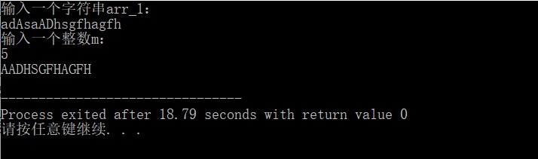

__

_______________________________________________________________________________

**4**

**.**

**#include <stdio.h>**

**#include <string.h>**

**struct leader**

**{**

**int n;**

**char name[10];**

**int score;**

**}**

**leader_H[3]={{1,"li",0},{2,"wang",0},{3,"zhang",0}};**

**int main()**

**{**

**char l[10];**

**for(int i=0;i<5;i++)**

**{**

**printf("**

请输入得票人姓名

**:**

**");**

**gets(l);**

**printf("**

**\**

**n");**

**for(int j=0;j<3;j++)**

**if(strcmp(l,leader_H[j].name)==0)**

**leader_H[j].score++;**

**}**

**for(int i=0;i<3;i++)**

**printf("**

编号

**%d**

姓名

**%10s**

票数

**%d**

**\**

**n",**

**leader_H[i]**

**.n,leader_H[i].name,leader_H[i].score);**

**return 0;**

**}**

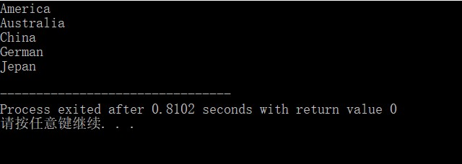

___________________________________________________________________________________

**5**

**.**

**#include <stdio.h>**

**#include <string.h>**

**struct plural**

**{**

**float real_part;**

**float imaginary_part;**

**}**

**a,b;**

**int main()**

**{**

**float sum;**

**printf("**

请输入

**a**

的实部和虚部：

**");**

**scanf("%f %f",&a.real_part,&a.imaginary_part);**

**printf("**

请输入

**b**

的实部和虚部：

**");**

**scanf("%f %f",&b.real_part,&b.imaginary_part);**

**printf("a,b**

的乘积为：

**%g+%gi**

**\**

**n",a.real_part*b.real_part**

**-**

**a.imaginary_part*b.imaginary_part,**

**a.real_p**

**art*b.imaginary_part+a.imaginary_part*b.real_part);**

**return 0;**

**}**

